**HP3D : Hybrid Peer-to-Peer Architecture in Support of Supply Chain Visibility**

Zhijie Li 1, Haoyan Wu1, Alvaro Esperanca1, Zhi Huang1

Jeffrey Tazelaar2, John Wassick2, Zina Ben Miled1

1 Electrical and Computer Engineering Department, Purdue School of Engineering and Technology, IUPUI

2The Dow Chemical Company

## ***Abstract***

During the process of supply chain system, it is significant to distribute information among each stakeholder on time, which is laggy nowadays to some degree. The scalability is limited by the non-expandable design that cannot handle extra information when threshold exceeded. In order to address the historical problems, the new system has been implemented with such technologies to brighten the each process of supply chain, to enforce the privacy protection of each transaction, to boost the scalability of the system: 1) Real time broadcast to each stakeholder, 2) Encrypted communication, organic connection and local no-SQL database, 3) Centralized P2P network, standardized protocol. We present a prototype of the supply chain visibility system with web-page based user interface above an application layer implemented by golang and javascript.

## ***Introduction***

The global supply chain is a complex and dynamic set of interactions and trade-offs between suppliers, manufacturing, warehousing, carriers, and customers to deliver the right product, at the right time, in the right condition. The data to support trade-off decisions to maximize profit, not just minimize costs, are spread across the global supply chain with ownership of the systems and underlying data varying based on the type of decision being made. The maturation of Electronic Data Interchange (EDI) has enabled automated transactional messaging between trading partners Enterprise Resource Planning (ERP) systems. Furthermore, the emergence of Supply Chain Operating Networks (SCON) has extended the availability of transactional data across members of the SC network based on the movement of goods. However, the value derived and success of SCON systems is directly proportional to the level of participation by a given industry sector or trading group. As companies, both big and small, venture in to new industries and sectors the ability to support multiple networks for supply chain visibility is both inefficient and costly [Heaney, 2014]. Furthermore, the consensus is that the current transactional layer provided through SCON is not sufficient to support the recurrent requirements for supply chain visibility and that a real-time information layer is needed to overcome these limitations [Kinaxis, 2014]. However, there is no clear consensus around the best approach to address the community need for supply chain visibility [EFT, 2015].

This paper proposes an efficient and scalable framework that supports total visibility in the physical distribution phase of the supply chain. Efficiency and scalability are achieved through:

* an event-based approach as opposed to the traditional transaction-based approach which leverages advances in sensor technology and the expanding trend of Internet of Things, and
* a peer to peer architecture that can be dynamically customized to accommodate a scalable number of small as well as large companies and takes advantage of recent advances in network technologies.

The proposed hybrid peer-to-peer physical distribution framework H(P3D) provide a seamless, plug and play, standardized digital integration across the different parties of the supply chain network. HP3D delivers the pseudo-real time status of each shipment and provide a better visibility of the physical distribution of goods. The architecture of the proposed HP3D is also scalable and can accommodate the volume and velocity expected when the real-time status of the shipment (and potentially the products in the shipment) is tracked.

Section 2 of this paper reviews previous related work. Section 3, ….

## ***Related work***

The industry is at a tipping point, where efficient network connections are being used to create step changes in efficiency and operability of SC’s across industries [Plambeck, 2012]. Current supply chain management system rely on centralized Supply chain operating network (SCON) [ref] and use the electronic data interchange (EDI)[3] as a standard for data exchanges . These best of class solutions in the systems and tools are beginning to overlap on the capabilities and industries served; thus creating an environment where end-users are required to adopt multiple systems based on the segment of the supply chain they are in and the industry they serve (or hope to serve). However, none of the current systems link transactional data to event based data while providing real time transparency.

E2Open [ref?] and SAP [ref?] (others ????) are examples of current leading edge supply chain systems that provide some well-developed functionalities including real-time shipment information update and interoperability with multiple enterprise resource planning (ERP) systems. These systems have cloud-based centralized architecture. Given the large amount of traffic that needs to be supported by a global supply chain system, a centralized architecture approach has several limitations including bounded scalability and affordability especially for small business. The P2P architecture proposed in this paper overcomes these limitation through a decentralized architecture that relies on mainstream technology which is readily accessible to small, medium as well as large businesses. In addition, the proposed framework allows private network to be established dynamically for the purpose of the physical distribution of a given shipment or set of related systems.

Sensor technology has evolved rapidly in the recent years making smart devices ubiquitous and affordable. These sensors deliver information about the environment in real-time[5]. In the case of physical distribution and the proposed framework, sensors are expected to be available throughout the route of the shipment starting from the supplier’s warehouse, to the carrier truck, and ending with the customer’s warehouse. At each of these locations, sensor aggregation tools (e.g. …. [ref]) are being use to deliver real time ground information. Our assumption is that the sensor aggregation system will forward events on real-time basis to the gateway of the proposed HP3D. These incoming events, trigger a process in HP3D that will distribute the information to the relative stakeholders. Furthermore, for each shipment H3PD creates a digital thread that parallels the real time status of the shipment making the physical distribution of the shipment completely transparent to the stakeholders.

While the P2P architecture have been widely used in several social media oriented applications (e.g., Napster[6], …. [], and [ ]) it has not been used in supply chain management. P2P architecture offer several characteristics that align with the mainstream vision of the proposed HP3D. These characteristics are discussed below:

* Security: In a typical client/server model, data is stored in a centralized location which can become vulnerable to breaches despite all the efforts for tightened security procedures in the server. In contrast, in a P2P model data is distribute across the network and none of the peers hold a global view of the entire system. Furthermore, information is being exchanged only between members of a personalized network under the specific context of given target shipment.
* Scalability: The client/server model is limited by the amount of transactions that can be handled by the server. In the case of the P2P architecture, each peer can play the role of a client and/or a servers as needed by the exchange with other peers [7]. This aspect of the architecture makes the system scalable. In the proposed HP3D system, the only centric component is the index server which maintains dynamic information about the IP addresses of the clients and is responsible for forward this information to the peers. Napster[6], Gnutella [] and ???? [] use this model. There are several variants of the P2P model and these are discussed at the end of this section.
* Fault-tolerance: The server in the centralized client/server model is a single-point-failure. Building fault tolerance around this model often involves redundancy of resources. HP3D also has a centralized index server and redundancy needs to be used for fault tolerance purposes. However, the index server has limited functionalities which does not entail a substantial resource investment compared to the duplication of the server in the client server model.

As previously mention there are several variations of the P2P architecture. Gnutella [ref] was the first pure P2P network. It was used for file sharing. Each peer kept its own index of other peers which helped improve the resilience of the model. However, it also created the potential for nodes to be flooded by queries that generate significant network traffic [6].

In the hierarchical P2P model, there are designated super nodes that manage the indices of the peers in each super node’s group [ref]. While the hierarchical P2P model addresses the vulnerability of the peers to network flooding, it suffers from an increase in complexity resulting from the management of multiple super nodes. The hierarchical model and its underlying organization of nodes into subgroups is ideal for applications that can take advantage of the proximity relationship requiring fast communication with nearest neighbors.

The third P2P model is the hybrid P2P [ref] which includes an index server that indexes all the active nodes in the network and deliver this information upon request to each peer. The hybrid P2P was designed to address the limitations of both previous two P2P models, namely the pure P2P and the hierarchical P2P.

For the supply chain physical distribution framework the hybrid P2P model was selected because of its resilience and ease of management while taking into consideration the large volume of small messages that will make up the network traffic of the system. The underlying network is also dynamic: It can develop and expand in response to customers placing orders and terminated when the delivery is completed.

Several previous project used the hybrid ?? P2P model to develop various application. For instance, in [8], this model was use to develop an emergency alert system using social networks. As in our proposed framework, the network is dismantled when the emergency terminates.

< add one or two more examples, How do these differ with your proposed approach ?? >

## ***Physical Distribution Workflow***

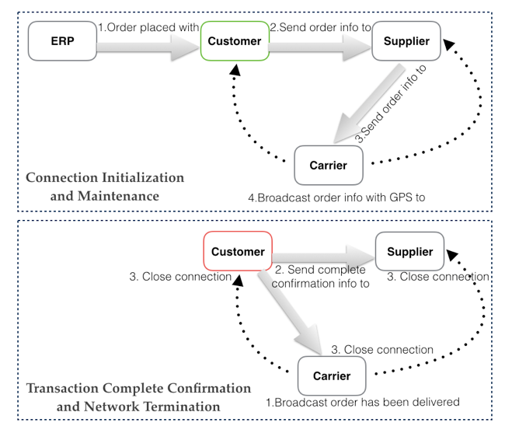

Figure 1: …….?????? (remove the ERP and the arrow and make sure that the figures are not cut-off. Make sure figure is readable. In general figure needs to be remade – not clear.

Given that physical distribution is the target domain for the proposed HP3D framework, we briefly describe the underlying processes of this segment of the supply chain in this section. Physical distribution is the transfer of goods from the supplier to the customer. It starts by the placement of an order (Figure 1) by the customer and concludes when this customer acknowledges receipt of the goods. The placement of an order can be initiated through a purchase order (PO) or a standing order that is issued from the customer’s ERP (enterprise resource planning) system. This step corresponds to the handover to the proposed H3PD and represents a transition from a transaction based interactions between the stakeholders (e.g. via the ERP) to a transparent interactions via H3PD. A carrier is selected and a logical shipment-centric network is established that includes the customer, the supplier and the carrier. Throughout the interaction, sensor information is collected and broadcasted to all participants. This information is usually local to each party and not available in real time to other members of the exchange. For example, sensor data will be send from the supplier’s warehouse as shipment is being prepared. This will provide the carrier with lead time to schedule pick up and the customer an update on the estimated arrival time of the goods. Similarly, an on-board message is not only processed internally by the carrier but also sent to the supplier and the customer enabling both to start having complete visibility on the shipment of the order. The sensor will continue to send status updates while the shipment is en-route.

As end-to-end supply chains span many geographies, modes and industries, the opportunity to provide a mainstream framework that can provide a cost effective, customized and scalable connectivity will be transformational for all supply chain participants.

## ***Architecture Overview***

The architecture of HP3D is shown in Figure 2. It is based on a collection of purpose-centric customized sub-networks that can be configured dynamically in real time. This is a departure from the traditional transaction based EDI systems. HP3D allows stakeholders to share information related to a given shipment and provides total visibility in the physical distribution segment of the supply chain.

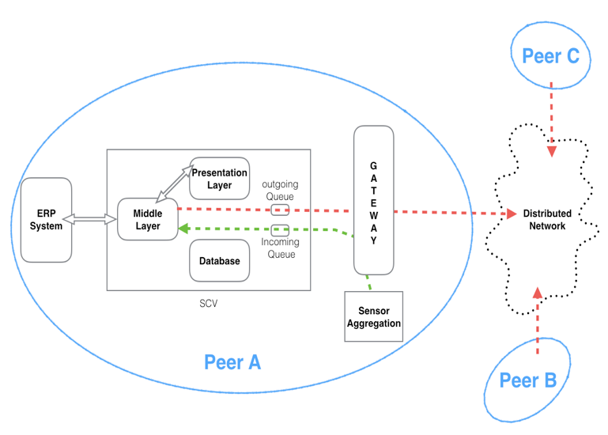

Figure 2: you need to add the index server and show the connection here

There are two main entities in the system: the index server and the peer. Each of these entities are described next.

* 1. **Index Server**

The role of the index server is to dynamically collect and share the IP addresses of the peers. We say index server is a light weight server since it does not interfere the communication between peers. In a particular transaction, the index server will only act as a yellow page. It is only responsible for giving the target IP address to the peer that needs to send an update information. In order to cooperate the dynamic IP environment index server need to keep every peer’s IP address updated. To achieve this goal, we designed a heartbeat message that is sent from client every 30 seconds. A peer sends the heartbeat message to the index server every 30 seconds, index server will rewrite the corresponding record of the client based on the information contained in the message. This design can reduces the ongoing network traffic. A peer does not have to send the update IP information to all other peers but only to the index server. Assume we have n peers in the system. Normally one peer has to send the IP update message to other n-1 peers. By using index server, the peer will only need to send one message to index server. As you can see that the number of messages have been reduced from a linear time to constant time.

You need more information here, how is it implemented, what are the innovation ???

* 1. **Peers**

The architecture of the peer is shown in Figure 2. While each of the peers can assume a different role for each individual transfer of goods, all peers have a unified architecture. A given peer may assume more than one role with respect to different transfers. For instance, a carrier in one transfer can also be a customer in another transfer. However, for a given transfer, these roles are fixed.

The presentation tier in the peer architecture (Figure 2) consists of a local HTTP server hosting a web application. The HTTP server is part of the middle layer and is responsible for processing the user requests and calling the functions based on the requests. The presentation tier is implemented using HTML, CSS, JavaScript and the Go programming language[ref].

The middle layer is responsible for four processes

* handling incoming client requests from the presentation tier
* receiving signal from the sensor gateway,
* generating new event and
* sending updated shipment information to other stakeholders.

Different sensors signal triggers different events. For example a GPS position received from the carrier sensor gateway will update the database and forward the new GPS location to the other stakeholders.

The third tier in the proposed HP3D is implemented using a mongoDB [9] database. MongoDB is a no-SQL database that consists of a set of collections. Each collection can hold a different type of documents. The number of attributes and their corresponding data size can vary from one document to the next. This feature made mongoDB the database of choice for this application because …..

* 1. **Data exchange template and management**

Data exchange in HP3D uses the JSON format [ref]. This format is also used by mongoDB which makes parsing, inserting and retrieving information from the database straightforward. HP3D handles two types of templates: basic information and order information.

Basic information is required for each client to register on the index server. This information consists of the customer ID, name and current IP. ????

The order information template (Figure 3) is used to track the shipment. Each order includes three main sections. The First section consists information about the participants (i.e. Customer, Supplier, and Carrier names, codes and IP addresses). As soon as these participants are identified, their corresponding IP address is retrieved from the index server and it will be continuously updated during the route. This capability is important as some of participants may be accessing the proposed system through mobile devices. In addition, this section includes the information about the order including the origin, destination, order date, pickup time and estimated time of arrival.

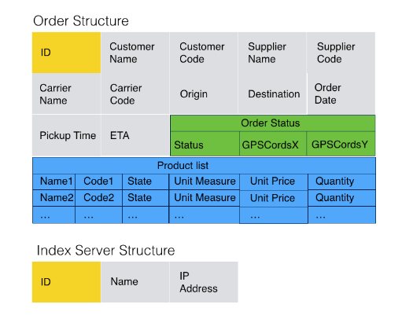

Figure 3, remove the index server structure and show the data exchange template in Json format. Do you check for each product if it was delivered . You can then consider an extension to be included in the future work that will allow your system to work at the product level. Assume that each product has an RFID tags this can be done.

The second section is the Order Status. This section includes the real time status information of a particular order including geolocation information, if available, and the status description. The status description …..

the order code, which distinguishes one from another. For the sake of simplicity, we used the object code generated by mongodb.

## The third section is the packing list which includes the product name, product code, (what is state ???), unit measure and quantity. This information is issued by the supplier. …

## 

## ***Example Scenario***

In order to test SCV, we set up a simple scenario. First we assume that the order has already been committed by those stakeholders included in the shipment. SCV comes out at the beginning of physical distribution. The supplier initiates the entire process by announcing the status of the preparation of the shipment. In our test we descript it as five stages” "on the ship", "off the ship", "on the dock", and "in the storage” "getting ready", "ready for pickup" (we assumed that the goods is coming from a ship). The supplier side SCV listens to any incoming signal. A new event is triggered, once a new signal is received from sensor aggregation. The supplier will update its own database and broadcast the newest information to other stakeholders who are involved in the shipment. The carrier will arrange a truck to pick up the shipment when it receives the "ready for pickup" signal from supplier. As soon as the truck picks up the goods, a new "picked up" signal will be generated by the truck and sent to supplier and customer both. We assumed that there is a GPS sensor installed on every carrier’s truck, and the truck will keep sending GPS signals to carrier and carrier will broadcast the signal to supplier and customer. We defined this particular status as "in transit". The status will not be updated while the shipment is in transit, but the GPS information will be shared between all stakeholders using the status struct defined. The carrier will send a delivery signal when the shipment is delivered to customer. The customer has to confirm the shipment manually. The reason is that customer needs to check if the goods under the shipment is in acceptable condition. The customer will accept/reject the shipment after they have checked it. Customer will manually confirm the status through SCV. At the end the shipment, data will remain in all stakeholder’s database for future using.

Authentication of users (how ?), what

## ***Conclusion***

EDI is the workhorse of the supply chain, automating Business-to-Business transaction for over 40 years. However, there is a significant gap in the performance and value derived from EDI causing an adoption gap across supply chain partners. The advent of financial transaction driven Supply Chain Operating Networks are taking hold and seeing strong adoption by leading SC companies. The current market is made up of best of class solution providers that have emerged based on their legacy solution offerings in a target market or supply chain modal segment. If interoperable solutions are not built, the industry risks fragmentation and multiple sources of the truth. Strong integration is required across the tools used to drive performance across the modes and in the functions that manage the supply chain; these include the systems and tools used for Purchasing, Finance, Planning, Manufacturing, Transportation Management, Risk Management, Supply Chain Sustainability, and Customer Service. This will be further complicated by the move from intermittent system based transactional data to real-time sensor based data triggering financial transactions.

Overall, the current supply chain systems, which uses electronic data interchange and value added network, are not suitable for current business environment since the size of companies grow larger and the information exchange process needs to be more efficient. In another word, the supply chain visibility needs to be increased by using different techniques. In order to accommodate the needs of current supply chain visibility, we developed the system called SCV.

SCV is a hybrid peer to peer and event based system. It is low cost, more affordable setup, scalable and more flexible compared with electronic data interchange and value added network. The system has the ability of real-time event update. There are still some developments need to be added to SCV. In order to make the system more secure, we need to add some security mechanism to the communication part. The database also needs some secure login mechanism as well. Overall the system demonstrated the method of satisfying the basic need of current supply chain system.

## **References**

[1] J. Mentzer, W. DeWitt, J. Keebler, S. Min, N. Nix, C. Smith and Z. Zacharia, "DEFINING SUPPLY CHAIN MANAGEMENT", Journal of Business Logistics, vol. 22, no. 2, pp. 1-25, 2001.

[2] B. Jerman-Blazic, "Security in value added networks - security requirements for EDI", Computer Standards & Interfaces, vol. 12, no. 1, pp. 23-33, 1991.

[3] The EDI Handbook, edited by M.Gifkins, D.Hitchcock, Blenheim Online, London, 1988, p.4

[4] N. Tohamy, L. M. Orlov, L. Herbert “Forrester Research: Supply Chain Visibility Defined”, 2004.

[5] "IEEE Internet of Things Journal", IEEE Internet of Things Journal, vol. 3, no. 3, pp. C2-C2, 2016.

[6]Chopra D., Schulzrinne H., Marocco E. and Ivov E. (2009). Peer-Peer Overlays for Real-Time Communication: Security Issues and Solutions, IEEE Communications Surveys & Tutorials, Vol. 11, No 1, First Quarter 2009.

[7] A. Crespo, et al., “Semantic overlay networks for P2P systems,” Technical Report, Computer Science Department, Stanford University, pp. 23-32, 2002.

[8] Y. Jung, R. Figueiredo and J. A. B. Fortes, "Emergency Response using Ephemeral Social Communities across Online Social Networks", EAI Endorsed Transactions on Collaborative Computing, vol. 1, no. 5, p. 150805, 2015.

[9] S. Kanoje, V. Powar and D. Mukhopadhyay, "Using MongoDB for social networking website deciphering the pros and cons", in *Innovations in Information, Embedded and Communication Systems (ICIIECS), 2015 International Conference*, Coimbatore, 2015.

<http://ieeexplore.ieee.org/xpls/icp.jsp?arnumber=7192924>